
Somerset Nursery School Newsletter
November 2025
Dear Families,
We have been celebrating Diwali in the Nursery. We have made Diva lamps using clay, decorating them with paint, and glitter. We have also made Rangoli patterns, and Bhakri bread to eat.

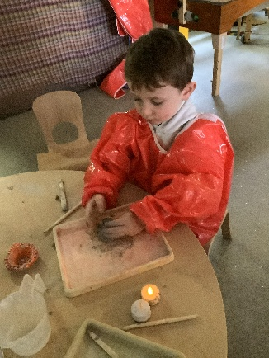 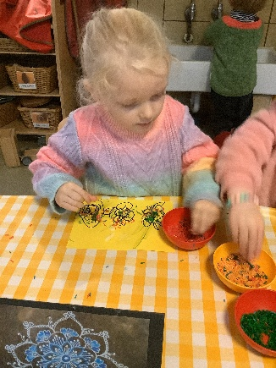 \\ \\\ \\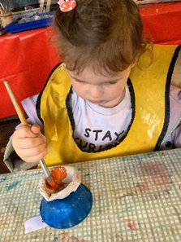\ 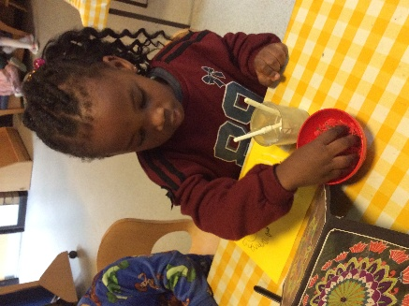
We have also been celebrating fireworks night in the Nursery. We have made some colourful firework pictures using a salad spinner, and then we watched a firework display in the garden.
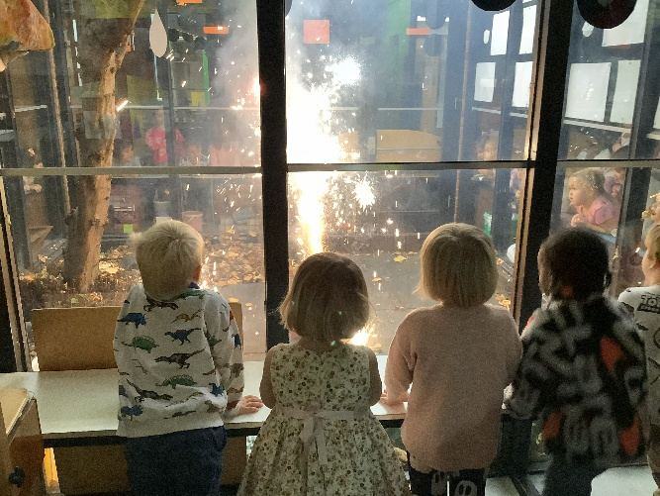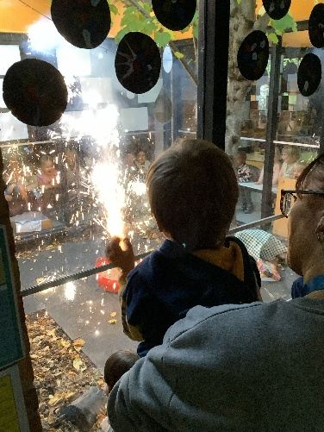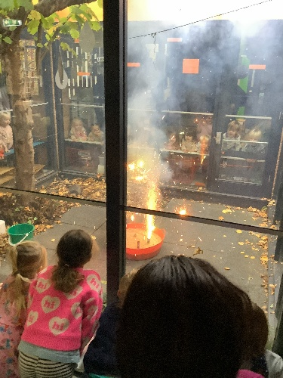
  Imagination Library  Dolly Parton’s Imagination Library is a free programme that gifts books to children. All titles in the Imagination Library are carefully selected by a panel of experts in early childhood development and reading. Each title is allocated to a specific age group, ensuring the books are age appropriate.  Once your child is registered, they will receive a free high-quality, age-appropriate book addressed to them in the post each month, until their 5th birthday, completely free of charge.  More information can be found at https://www.wandsworth.gov.uk/imagination-library  Parking Notice  Please take a look at the map below. We are keen to maintain good relationships with all our local residents and reduce air pollution. Please do not park or idle in the private parking bays or on the slip road circled in red.  Please consider parking further from the school and walking the last part of your journey. We have a large buggy park to store pushchairs, scooters and bikes. | SAVE THE DATE- Christmas Events  Tuesday 16th December- Christmas Dinner  Children and staff will enjoy a delicious traditional Christmas dinner together at school.  Wednesday 17th December- Christmas Singing  Parents and family members are invited to watch the children sing Christmas Carols in the garden. Please join us for singing and a warm mince pie!  Friday 19th December- Children’s Christmas Party  School will be closed in the morning and all children will arrive at 1pm, collection at 2:45 so you can be with your child when a very special visitor arrives!  Further details about the menu, singing and party will be sent out in December.  Snack Donations    We regularly include food based activities in our curriculum. If you would like to contribute towards the cost of ingredients please put your donation in an envelope in the green snack donation box in the foyer. Donations can also be made via bank transfer. Fiona is available to help in the office if you have any questions. Thank you for your generous donations!    Breakfast is open from 9:15-9:45 each morning and children are offered a range of healthy cereals, bagels, crumpets and toast.  All food and drinks are provided by the school. Please make sure there are no food items in your child’s bag as the bags are unsupervised and we have children with allergies. If you have any questions please speak to Russell or Kellie.
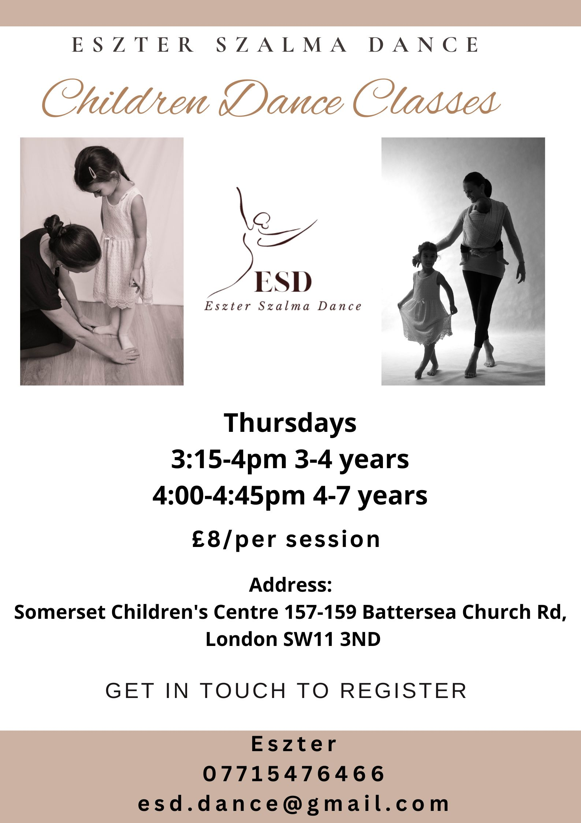 | Parent Workshops  This term we are offering parent workshops to share information about our curriculum and tips on supporting learning at home.  Positive Behaviour  Friday 21st November, 9.30-11.00  Fussy Eaters  Wednesday 26th November, 9.30-10.00  Workshops will be facilitated by Kellie Schrader, Headteacher.  Parent Teacher Meetings  Autumn term pupil progress meetings will be conducted over a two week period between Monday 1st December and Friday 12th December.  We are offering meetings in person at school and via telephone. Your child’s key worker will book this directly with you over the coming weeks.
If you are concerned about a child’s wellbeing or have a question about safeguarding please contact Kellie Schrader, Headteacher. Outside of school hours please contact Wandsworth MASH: 020 8871 6622 mash@wandsworth.gov.uk

